**Title: Simple Blogging Platform**

**FLOW DIAGRAM:**

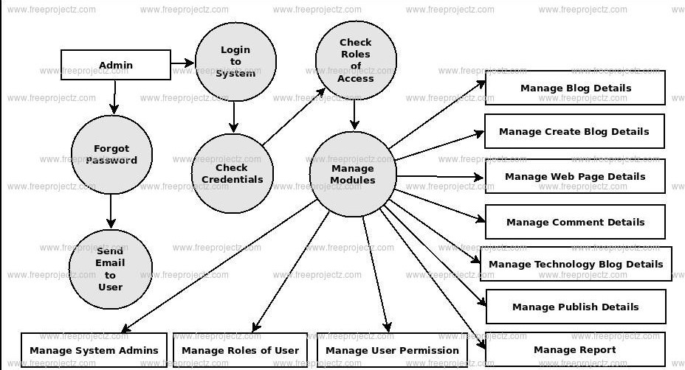

**High-Level Documentation**:

**Overview**:

The Simple Blogging Platform allows users to create, publish, and manage blog posts. It provides an intuitive interface for writers to share their thoughts and engage with readers.

**Features**:

**User Registration and Authentication**: Users can sign up for accounts and securely log in to access the platform.

**Blog Post Management**: Users can create, edit, delete, and publish blog posts.

**Commenting System**: Readers can leave comments on blog posts to interact with authors and other readers.

**Responsive Design**: The platform is designed to be accessible on various devices, ensuring a seamless reading and writing experience.

**Technologies Used**:

**Frontend**: HTML, CSS, JavaScript

**Backend**: Node.js, Express.js

**Database**: MongoDB

**Dependencies**:

**Express**.**js**: Web application framework for Node.js

**MongoDB**: NoSQL database for storing user data, blog posts, and comments

**Mongoose**: MongoDB object modeling tool for Node.js

**bcrypt**: Library for password hashing and authentication

**JSON Web Tokens (JWT)**: Secure authentication mechanism for web applications

**Deployment**:

The platform is deployed on a cloud platform such as Heroku or AWS to ensure accessibility to users from anywhere with an internet connection.

**Low-Level Documentation:**

**Module**: User Authentication

**Purpose**:

The User Authentication module handles user registration, login, and authentication processes to ensure secure access to the platform.

**Components**:

**Registration Form**: Collects user information including username, email, and password.

**Authentication Middleware**: Validates user credentials during login and ensures authenticated access to protected routes.

**Password Hashing**: Utilizes bcrypt library to securely hash and store user passwords in the database.

**JSON Web Tokens (JWT):** Generates and verifies JWT tokens for authenticated user sessions.

**Dependencies**:

**Express.js**: Handling HTTP requests and routing

**bcrypt**: Password hashing and authentication

**JSON Web Tokens (JWT)**: Secure user session management

**Module**: Blog Post Management

**Purpose**:

The Blog Post Management module enables users to create, edit, delete, and publish blog posts.

**Components**:

**Post Model**: Defines the structure of a blog post including title, content, author, and publication status.

**CRUD Operations**: Implements Create, Read, Update, and Delete operations for blog posts.

**Post Routes**: Defines RESTful API endpoints for interacting with blog posts.

**Input Validation**: Ensures data integrity by validating user input before processing CRUD operations.

**Dependencies**:

**Express.js**: Handling HTTP requests and routing

**Mongoose**: Object modeling tool for MongoDB

**MongoDB**: NoSQL database for storing blog posts

This documentation provides a detailed overview of the blogging platform's functionality, technologies used, and the internal components responsible for its operation.

**Conclusion**:

The Simple Blogging Platform is a web application designed to facilitate the creation, publishing, and management of blog posts. It offers a user-friendly interface for both writers and readers, allowing for seamless interaction within the blogging community.

The platform's high-level documentation outlines its core features, including user authentication, blog post management, commenting system, and responsive design. It highlights the technologies used such as Node.js, Express.js, MongoDB, and dependencies like bcrypt and JSON Web Tokens for secure authentication.

Furthermore, the low-level documentation delves into the specific modules and components responsible for the platform's functionality. It details the user authentication module, which ensures secure access to user accounts, and the blog post management module, which handles the creation, editing, and publication of blog posts.

Overall, the Simple Blogging Platform serves as an accessible and efficient tool for users to share their thoughts, engage with readers, and contribute to the online blogging community. Its robust architecture and intuitive design make it suitable for aspiring writers, bloggers, and content creators alike.